48.Directions:
Write an essay based on the following chart. you should
1) interpret the chart and
2) give your comments.
You should write about 150 words on the ANSWER SHEET.(15 points).
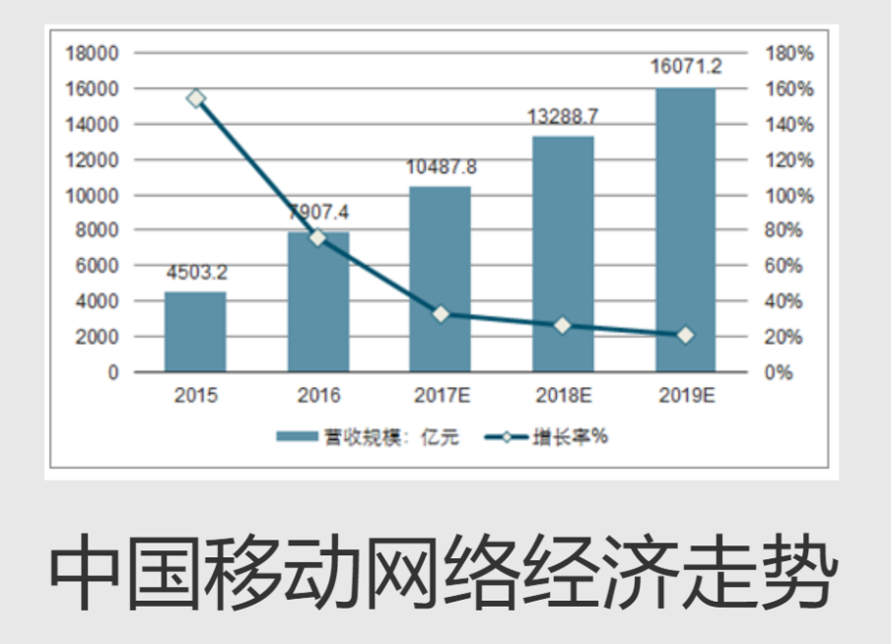

As is subtly mirrored in the chart, the revenue scale of Mobile Internet in China has rocketed up steadily from 2015 to 2019, while the increasing rate has dropped slightly year by year. What the diagram conveys goes far beyond merely the prosperity of the mobile internet economy. Instead, it reflected the ever increasing needs of the mobile internet. Several factors weigh heavily for this round of economic growth(phenomenon), among which two major ones suspended on the top of the list which should never be overlooked.
In the first place, owing to the prosperity of the economy in China, the whole country promotes the policy of mobile payment. Based on a most recent study, a growing body of evidence showed that most successful social elites, who used cellphones to pay, admitted that they enjoyed the convenience brought by the mobile internet. Meanwhile, due to the busy schedule of university life, college students, who are engaged in studying, must find it helpful for them to improve efficiency when using the internet on the smartphone. A classic case in point is one of my classmates, who always uses cellphones to search for useful information. As a result, he paid a lot on the cellphone to buy the information.
In view of the arguments above, we can safely draw a conclusion that with the ever-increasing material and cultural life, the scale of revenue of mobile internet in China will keep growing in the forthcoming decade.

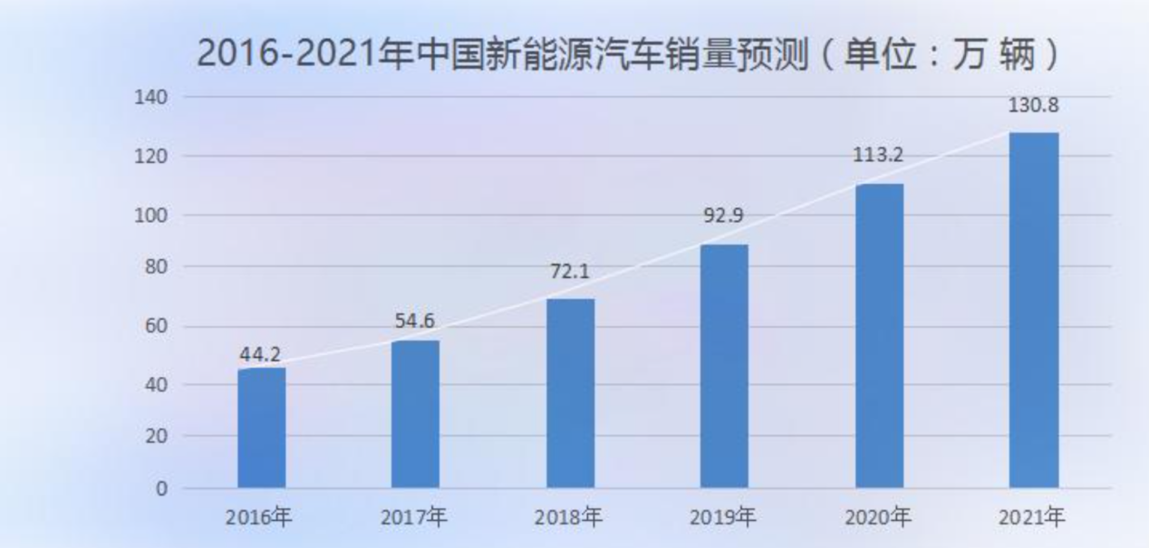
As is subtly mirrored in the chart, the sale of new energy vehicle in China has rocketed up steadily from 2016 to 2021. What the diagram conveys goes far beyond merely the prosperity of car market. Instead, it reflected the ever increasing needs of new energy. Several factors weigh heavily for this phenomenon, among which two major ones suspended on the top of the list which should never be overlooked.
In the first place, owing to the prosperity of the economy in China, the whole country promotes the policy of environmental protection. Based on a most recent study, a growing body of evidence showed that most successful social elites, who used electric vehicles, admitted that they enjoyed the subsidies brought by the new energy car. Meanwhile, less greenhouse emission will be produced. To some degrees, we’re making contributions to the global climate change. Thus, from this standing point, there is nothing more beneficial and challenging than the new energy car.
In view of the arguments above, we can safely draw a conclusion that with the ever-increasing material and cultural life, the scale of revenue of new energy car in China will keep growing in the forthcoming decade.

